Assignment 01 – Version 3.0 **Acquire a Web Host & Domain Name**

Students are required to have access to a Web Host account that they use to create and manage multiple CMS websites. In our first IT320 class, during class we did Activity 01, and we signed up for a shared web host account. In this assignment, you will record information about these accounts and verify that our new shared web host account has an “admin” email account for its domain.  
  
Additionally, we will do a few PHP problems, to test your understanding of the PHP material we covered in class.   
If you have difficulties completing this assignment, please inform the instructor and consider working with DePaul tutors.

**Instructions for completing template:***Replace* **[bracketed red text]** *with the requested information and change the* ***red text to black text.*** *Do not include full screen shot images, or full screen shots that are reduced in size. Use a snippet tool to capture parts of the screen and insert those images into the template.  
Please answer all questions.***Please do not alter template numbering.**

**PART A – Student & Assignment Information**

**1. Student Name: [Umar Khan] [A01]**

**2. Student Contact Information:   
[ukhan17@depaul.edu] [A02]  
[872-888-5572] [A03]**

**Go back to the instructions and begin working on part B.**

**Part B – Shared Web Host Information**

1. Which shared web host account did you establish? Please list their name below.  
 [Namecheap] **[B01]**

**Part C – Student Shared Web Admin Email Account Check**

Most shared web hosts use Softaculous build scripts. These scripts are not the same as building WordPress from the Automatic (the company that owns WordPress) default build script.   
One of the default Softaculous options is the “admin email”.  
Softaculous has a default value of admin@“your domain name”.  
So for your WordPress sites to build and work properly, your web host account must have this default email account. In the tutorial we checked and made one.   
  
In this part of the assignment, I want you to provide proof that the admin email account exists.   
Pantheon users can skip this part without losing any points.

1. Does your new web host account have an email account named “admin”?   
 [Yes] **[C01]  
I’m asking if there is an email account named “admin”, [admin@yourdomain]?  
[For Pantheon – Put Pantheon-YES]**

**2. Did you create a forwarder email account**[Yes] **[C02]**

**3. Provide a screen capture of your Email forwarder accounts page that displays the forwarder email information**[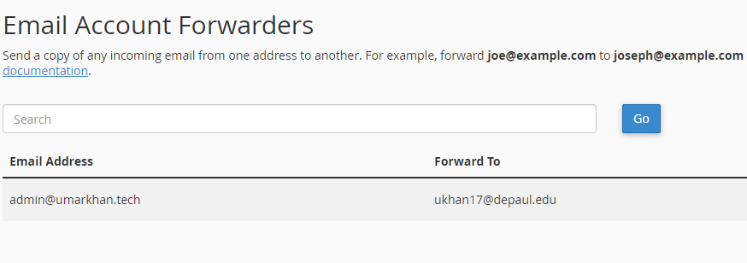] **[C03]**

**Go back to the instructions and begin working on part D.**

**Part D – INTRO to PHP Questions and Answers:**

1. List the five PHP variable naming rules below [D01]

|  |  |
| --- | --- |
| 1 | A variable name must start a letter or the underscore character. |
| 2 | A variable name cannot start with a number. |
| 3 | A variable starts with the $ sign, followed by the name of the variable. |
| 4 | A variable name can only contain alpha-numeric characters and underscores (A-z, 0-9, and _ ). |
| 5 | Variable names are case-sensitive ($age and $AGE) are two different variables. |

1. This question has two parts.   
   Part 1: Of the following PHP variables, which are valid and which are invalid? Part2: **If the variable is invalid, please list why it is invalid?  
   (HINT: there may be more than 1 error on the variable) [D02]**

|  |  |  |  |
| --- | --- | --- | --- |
| **No.** | **Variable** | **Is Valid (Yes/No)** | **If invalid, reason(s) why** |
| **1** | **$myNameIsBill** | **Yes** |  |
| **2** | **$#name-first** | **No** | **Because it has a special character hashtag #.** |
| **3** | **$name_first** | **Yes** |  |
| **4** | **$name-first** | **No** | **Because it has a special character dash -.** |
| **5** | **$ lostAmount** | **No** | **Because it has a space after $ sign.** |

**3.** Write PHP code that defines a PHP variable named $cost and assigns the $cost variable the value of 5.01 and then in another (different) PHP statement **use the echo function to display the $cost variable**. Write your code and test it in a web emulator (tester) like phptester.net. Take a screen capture of the code and output window and paste the capture in the box below, where it says  
<Your PHP capture here>

|  |
| --- |
| **[D03]** |
|  |

**4.** Is the variable $1234Abc a valid variable and if not, why not?   
Write your code and test it in a web emulator (tester) like phptester.net. Take a screen capture of the code and output window and paste the capture in the box below, where is says  
<Your PHP capture here>

|  |
| --- |
| **[D04]** |
| <Your ANSWER to “is it valid and if not why not” here> |
| It is an invalid variable because it starts with the numbers. |
|  |

**Go back to the instructions and begin working on part E.**

**Part E – Questions** about IT320 and WordPress CMS

Please write a few sentences, in your own words, to answer the following questions. Please do not copy and paste content from the web. Please write your answers in the box below each question. Most of these questions are from the assigned readings and D2L presentations.

1. List and describe 3 attributes (features) of Content Management Systems (CMS)? [E.1]

|  |
| --- |
| 1. Usability: CMS tools are simple to learn to create good and fully functional websites. 2. Role based security: CMS permits you to design different types of sites administration capabilities depend on privileges. 3. Extensibility: CMS permits you to add further functionality through plugins and themes. |

1. Define and give an example of extensibility as it pertains to content management systems? [E.2]

|  |
| --- |
| Extensibility: CMS permits you to add further functionality through plugins and themes. For instance, if a person does not have much coding experience, CMS tools can help them add additional functionality. |

1. Each CMS website is actually composed of two websites. List and describe the 2 different websites associated a CMS website and what are their purposes? [E.3]

|  |
| --- |
| Frontend (CDA) and Backend (CMA)  Frontend is the website that users can see.  Backend is the website that only allows the administrators to see, manage, and maintain the content for the website. |

1. List and describe 3 benefits and 3 risks of using CMS websites? [E.4]

|  |
| --- |
| Benefits:   1. CMS tools are open source with zero cost. 2. Content and settings are stored in a database where changes can be made without losing the data. 3. CMS are simple to learn and use.   Risks:   1. Content is stored in a database which adds latency to content delivery. 2. Since it is an open source, it can be unsafe and have unfixable bugs. 3. Open-source CMS is hosted on the web, which can be expensive. |

1. List and describe 3 differences between CMS websites and static HTML websites? [E.5]

|  |
| --- |
| 1. CMS sites do not have any content as static files. 2. CMS uses database to retrieve content and settings on the website. 3. CMS does not require any coding skills and experience to use where HTML does. |

**Go back to the instructions and begin working on part F.**

**Part F - Assignment - Wrap Up:**

1. **Did you have any problem or issues completing this assignment besides time management issues:   
   [No] [F01]**  
   If you answered yes to this question, please elaborate and be specific.  
   If you had trouble with a specific question, please identify it by number and explain what you did not understand or had problems with.  
   I can only improve this assignment with your help.
2. **If you answered yes to this question, please elaborate and be specific.  
   If you had trouble with a specific question, please identify it by number and explain what you did not understand or had problems with.  
   I can only improve this assignment with your help.**

**[List problems here] [F02] *Only if you answered yes to F01**

**If you have questions or issues about this assignment please contact the instructor immediately.**   
Michael H Chase  
Mobile: 847-878-6225  
Office: 312-362-1352  
Email: [mchase2@cdm.depaul.edu](mailto:mchase2@cdm.depaul.edu)

Submit your completed template to D2L dropbox for assignment 01.

If you prefer not to navigate by hand to the D2L dropbox, take advantage of the dropbox link in the D2L Module 01 Assignment 01 section. This link will take you to the correct assignment dropbox location.

**Codeanywhere sub-account password and verification steps.**Before you can work next week’s tutorial or assignment, you must complete the Codeanywhere sub-account setup process.   
This includes (first) creating an account password and (second) resending and replying to a verification email. Details are in the Module 01 presentation:  
“M01 -06- Codeanywhere Account Signup”.   
Please follow through with completing the Codeanywhere new account set ASAP. Do not wait on this until it too late.   
The first Codeanywhere email link expires and if you run into issues because you waited too long, you may be late submitting the second assignment.